Farakh Farooq

[farakhfrq@gmail.com](mailto:farakhfrq@gmail.com)

**✅ Step 1: Check Current Logged-in User and System Info**

**Command:**

**whoami**

**uname -a**

**Explanation:**

**- whoami:**

**Displays the username of the currently logged-in user.**

**It helps verify that you're working under the correct account.**

**- uname -a:**

**Shows detailed system information such as:**

**• Kernel version**

**• Hostname**

**• Architecture**

**• OS type**

**Useful before installations or for troubleshooting.**

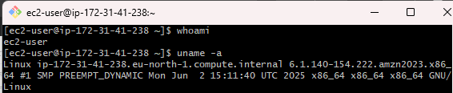

**✅ Step 2: Navigate to /projects and List Contents**

**Command:**

**cd /projects**

**ls -l**

**Explanation:**

**- cd /projects:**

**Changes the working directory to /projects so you can manage project files.**

**- ls -l:**

**Lists all files and folders with detailed info:**

**• Permissions**

**• Owner and group**

**• File size**

**• Last modified time**

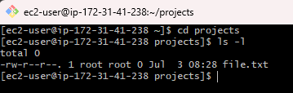

**✅ Step 3: Create a New Project Directory and Verify**

**Command:**

**mkdir projectB**

**ls -l**

**Explanation:**

**- mkdir projectB:**

**Creates a new directory named 'projectB' inside /projects.**

**- ls -l:**

**Verifies that 'projectB' now exists and shows details like:**

**• Owner**

**• Permissions**

**• Creation time**

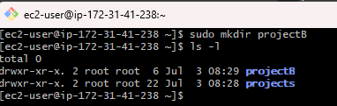

**✅ Step 4: Create a Sample File Inside projectB**

**Command:**

**touch projectB/README.txt**

**echo "Welcome to Project B" > projectB/README.txt**

**cat projectB/README.txt**

**Explanation:**

**- touch projectB/README.txt:**

**Creates an empty file called README.txt inside projectB.**

**- echo "Welcome to Project B" > projectB/README.txt:**

**Writes the text into the file (overwrites any previous content).**

**- cat projectB/README.txt:**

**Displays the content of the README.txt file to confirm the write.**

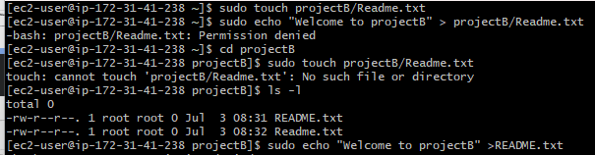

**✅ Step 1: Create a New User 'john' and Add Him to Group**

**Command:**

**sudo useradd -m -G developers john**

**sudo passwd john**

**Explanation:**

**- sudo useradd -m -G developers john:**

**• Creates a new user named 'john'.**

**• The `-m` option creates a home directory for john.**

**• The `-G developers` option adds john to the 'developers' group.**

**- sudo passwd john:**

**• Sets a password for the user 'john'.**

**• You'll be prompted to enter and confirm the password.**

**✅ Step 2: Verify User and Group Membership**

**Command:**

**id john**

**Explanation:**

**- id john:**

**• Displays the UID (User ID), GID (Group ID), and all groups that the user 'john' belongs to.**

**• Useful to confirm that 'john' was successfully added to the 'developers' group.**

**Example Output:**

**uid=1002(john) gid=1002(john) groups=1002(john),1003(developers)**

**✅ Step 3: Change Group Ownership of projectB Directory**

**Command:**

**sudo chown :developers /projects/projectB**

**Explanation:**

**- sudo chown :developers /projects/projectB:**

**• Changes the **group ownership** of the 'projectB' directory to the 'developers' group.**

**• The colon (:) before the group name means: keep the current user owner but change the group.**

**✅ Step 4: Set Proper Permissions for Group Access**

**Command:**

**sudo chmod 770 /projects/projectB**

**ls -ld /projects/projectB**

**Explanation:**

**- sudo chmod 770 /projects/projectB:**

**• Sets the directory permissions to:**

**- Owner: read, write, execute**

**- Group: read, write, execute**

**- Others: no access**

**• Ensures only the owner (e.g., root) and group (developers) can access or modify files.**

**- ls -ld /projects/projectB:**

**• Displays permission details of the directory.**

**• Confirms the change took effect.**

**Example Output:**

**drwxrwx--- 2 root developers 4096 Apr 25 10:10 projectB**

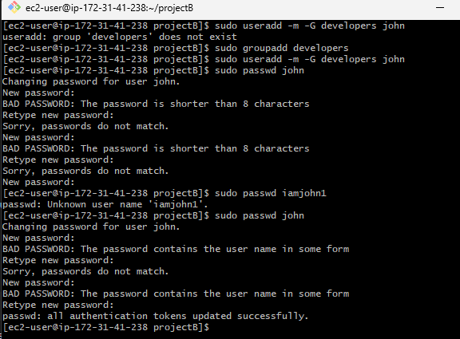

**✅ Step 1: Change Ownership of projectB to john**

**Command:**

**sudo chown john:developers /projects/projectB**

**Explanation:**

**- This command changes both the **user owner** and the **group owner** of the directory.**

**- `john:developers` means:**

**• User 'john' becomes the new **owner** of projectB.**

**• Group ownership is set to 'developers'.**

**- Only the user (john) and group members (developers) will have access based on the current permissions.**

**✅ Step 2: Verify the Ownership Change**

**Command:**

**ls -ld /projects/projectB**

**Explanation:**

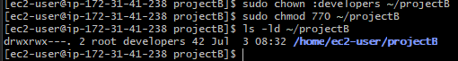

**✅ Step 1: Check System Uptime**

**Command:**

**uptime**

**Explanation:**

**- Displays how long the system has been running since the last reboot.**

**- Also shows:**

**• Current time**

**• Number of logged-in users**

**• Load average (CPU load over the last 1, 5, and 15 minutes)**

**Example Output:**

**10:20:11 up 5 days, 3:45, 2 users, load average: 0.10, 0.20, 0.30**

**✅ Step 2: Monitor Disk Usage**

**Command:**

**df -h**

**Explanation:**

**- Displays the amount of **disk space used and available** on all mounted file systems.**

**- `-h` stands for "human-readable", showing sizes in GB/MB.**

**Key columns:**

**• Filesystem – The disk partition**

**• Size – Total size**

**• Used – Used space**

**• Avail – Free space**

**• Use% – Usage percentage**

**• Mounted on – Mount point**

**Example Output:**

**Filesystem Size Used Avail Use% Mounted on**

**/dev/sda1 50G 20G 30G 40% /**

**✅ Step 3: Check Memory Usage**

**Command:**

**free -m**

**Explanation:**

**- Displays memory usage in **megabytes**.**

**- Columns show:**

**• Total – Total physical memory**

**• Used – Memory currently used**

**• Free – Memory not used**

**• Shared – Memory shared between processes**

**• buff/cache – Memory used for disk buffers/cache**

**• Available – Memory available for new processes**

**Example Output:**

**total used free shared buff/cache available**

**Mem: 16000 6000 7000 1000 3000 9000**

**✅ Step 4: Monitor Running Processes**

**Command:**

**ps aux --sort=-%mem | head -5**

**Explanation:**

**- `ps aux`: Lists all running processes with full details.**

**- `--sort=-%mem`: Sorts processes in descending order of memory usage.**

**- `head -5`: Limits the output to the **top 5 memory-consuming processes**.**

**Useful for:**

**• Identifying memory-hogging applications**

**• Troubleshooting performance issues**

**Example Output:**

**USER PID %CPU %MEM VSZ RSS TTY STAT START TIME COMMAND**

**root 1023 1.2 5.5 400000 88000 ? Ssl 10:00 0:30 /usr/bin/java**

**root 1105 0.8 3.2 300000 51200 ? Ssl 10:05 0:20**

